Arbaminch University
Faculty Of Engineering
Department of Computer Science and Information Technology

Comp312 – Computer Graphics

Chapter 7 Handout – 3-D Graphics

Introduction

So far most of the concepts we have discussed in this course have been equally applicable to 2-D and 3-D graphics. However, most graphics is performed in 3-D and there are some specific issues that only arise when dealing with 3-D graphics. This chapter highlights some of these issues and outlines some techniques for tackling them. First, we give a brief overview of 3-D graphics concepts, and then we will look in more detail at some specific techniques. Where appropriate, as algorithms are introduced, we will show how they can be used in the OpenGL graphics package.

Overview of 3-D Graphics Concepts

Projections

We have already introduced the idea of a projection transformation in Chapter 5. We know that projections are used to convert 3-D object coordinates into 2-D image coordinates, and that there are two basic types of projection:
- Perspective projection – All projection lines converge to a point, and objects that are further away from the camera appear smaller on the image plane.
- Parallel projection – All projection lines are parallel, and objects that are further away do not appear smaller on the image plane. Parallel projections can be either orthographic or oblique.

Figure 1 shows some examples of perspective and parallel projections. Figure 1(a) shows a screenshot from the popular computer game Doom. This uses a perspective projection, as we can see from the fact that the lines on the floor converge to a point in the distance. Perspective projections produce more realistic images, and are common in first-person games such as Doom (i.e. games where you view the world as if you were a character in it). Figure 1(b) is a screenshot from the strategy game Age of Empires. In this case a parallel projection is used. If you follow the lines at the edges of the buildings you will see that they run parallel to each other in the image, and as the distance from the camera increases they remain parallel. Parallel projections make it easier to judge the relative sizes of objects, which can be useful in some applications (e.g. CAD programs and some games). Figure 1(c) is not actually a computer-generated image at all. It is a painting by Canaletto called The Piazza of St. Mark, Venice, and was painted in 1735-45. Again we can see the lines of the tops of the buildings to either side of the square converge to a single point (this is known as one-point perspective). Actually projection transformations are not an invention of computer scientists. Computer scientists and mathematicians have simply formulated and implemented what artists have known about and used for centuries. Figure 1(d) shows another screenshot, this time from the game Tomb Raider: Legend. Again, this uses a perspective projection for realism, as we can see from the walls of the chamber converging towards the green light in the distance.

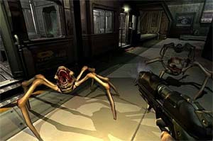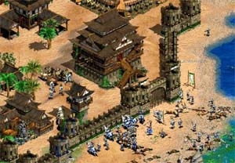
(a) (b)

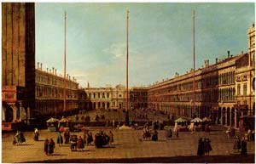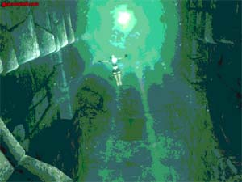
(c) (d)

Figure 1 - Perspective and Parallel Projections

Rendering Styles

As well as defining the 3-D to 2-D projection, we also need to decide what style to render our picture in. Recall that most objects are represented using a mesh of convex polygons. Wireframe rendering refers to drawing only the outlines of the polygons, allowing the viewer to “see through” the object to whatever lies behind. Solid rendering (or surface rendering) refers to drawing the polygons as solid objects.

Wireframe rendering can lead to an ambiguity in depth perception. Consider Figure 2. The pyramid shape to the left (rendered in wireframe) can be perceived in two ways, as illustrated by the two solid rendered pyramids to the right. Wireframe rendering can be useful, especially for design applications, but often we need a way to overcome this depth ambiguity.

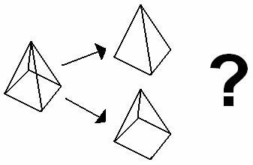

Figure 2 - Ambiguity of Depth Perception in Wireframe Rendering

One possible answer to this problem lies in depth cueing. Depth cueing simply means giving some extra information (a cue) to help the viewer perceive the object correctly. A number of techniques exist for depth cueing. One possibility is to vary the intensity of the pixels with distance from the camera, i.e. draw points further from the camera with a lower intensity (brightness). Figure 3 shows examples of this form of depth cueing. Figure 3(a) shows the same pyramid object we saw in Figure 2, but this time with the pixel intensity varied with depth. The ‘correct’ perception is now much easier to achieve. Figure 3(b) shows a similar technique applied to a wireframe rendering of a teapot.

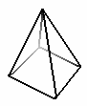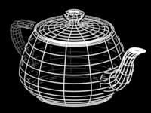
(a) (b)

Figure 3 - Depth Cueing by Varying Intensity with Distance from the Camera

In fact, a similar technique to depth cueing can also be used for solid rendering. Figure 4 shows a screenshot from the action game Turok. This uses a technique known as fogging to achieve better depth perception. We can see that the trees in the distance appear faint, as if seen through a fog, when compared to the trees and the soldier in the foreground. Fogging can be useful for adding extra realism to scenes, and also for improving rendering efficiency: if objects are not visible through the fog beyond a certain distance then they can be clipped using a far clipping plane, thus reducing processing time.

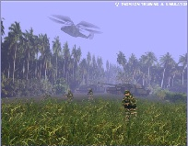

Figure 4 - Depth Cueing by Fogging

An alternative technique to depth cueing for wireframe rendering is to somehow identify which primitives are ‘visible’ and which are ‘invisible’, and then rendering ‘invisible’ primitives in a different style. For example, Figure 5 shows two alternative ways of improving the depth perception of the pyramid from Figure 2: one renders ‘invisible’ primitives in a lower (but uniform) intensity, and the other renders them using dashed lines. Alternatively, with a colour display ‘invisible’ primitives could be drawn in a different colour to ‘visible’ ones. Whatever the approach, we need some way of deciding if a primitive is ‘visible’ or ‘invisible’ before we can use these techniques.

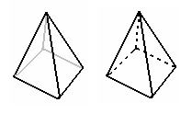
Figure 5 - Identifying Visible Primitives by Drawing Style

We also need to detect if a primitive is visible or not when using surface rendering. In this case, we need to detect ‘invisible’ surfaces so that they can be ignored (i.e. we only render visible surfaces). This process is known as visible surface detection, or hidden surface elimination, and will be examined in Section 3.

In addition to determining whether or not a surface should be displayed, we also need to decide how to shade the surface to make it appear realistic. This involves considering what light sources there are in our scene (see Section 4.1), how our surface reflects light (see Section 4.2), how we choose to vary the shading within each polygon (see Section 5) and what texture our surface has (see Section 7). All of these considerations will be dealt with in more detail in the proceeding sections. But first, we will briefly examine how we can represent our 3-D objects ready for rendering.

Object Representation

We have already mentioned that most objects in 3-D graphics are represented using a polygonal mesh, but this is not the only possibility. In general terms, we can identify two types of object representation:
- Boundary representations (b-reps) – Only the surface/boundary of the object is stored, normally using a set of smaller primitives.
- Space-partitioning representations – The volume of the object is hierarchically broken down into smaller sub-regions, until we reach basic 3-D primitives such as cubes, spheres, etc.

Polygonal meshes are one example of a b-rep, in which the primitives are normally convex polygons. Another possibility for b-reps is to represent the surface using spline patches – these are small pieces of curved surface represented by polynomial equations.

In this course we will first briefly examine an example of a space-partitioning representation, and then we will concentrate on the most common object representation, the polygonal mesh.

Octrees

An example of a space-partitioning representation is the octree. Octrees are actually a 3-D extension of a 2-D representation known as a quadtree. Therefore we will first introduce quadtrees and then describe how they can be extended to 3-D.

Quadtrees represent an image by a tree data structure, formed by successively subdividing the image into four subregions, until each subregion is homogeneous. Each subregion is represented by a node in the tree. At each iteration of the algorithm, a subregion is considered (commencing with the entire image) and a node created in the tree: if the image region is homogenous (i.e. the entire subregion of the image has the same colour, material, etc.) then this colour is stored in the node and no child nodes are generated; if it is not homogeneous then the region is further divided into four subregions, four child nodes are generated in the tree and the algorithm recursively executed for each of them. This process is illustrated in Figure 6. First we subdivide the entire image, then region 3 is subdivided further into four subregions, and then one of these subregions is subdivided further. At this stage one of the subregions is found to be homogeneous and so we stop subdividing and store its colour in the node (in this case, red). To complete this algorithm we would need to continue subdividing every subregion until only homogeneous regions are left. The homogeneous regions represent leaf nodes in the tree.

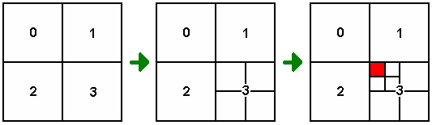

Figure 6 - Subdividing an Image to Construct a Quadtree

Octrees are a simple extension of this idea into 3-D. Whereas in 2-D each region is subdivided into four subregions, in 3-D it is divided into eight subvolumes, as illustrated in Figure 7. This process continues until all subvolumes are homogeneous. In Octrees each subvolume is known as a voxel, or volume cell (this is similar to the term pixel, or picture cell, in 2-D). When using octrees to represent objects, if a subvolume does not overlap with the object at all then the corresponding tree node is assigned a special void value.

Octree representations have the advantage that they are capable of representing the interior of the object as well as just the surface. Therefore they are commonly used in applications where such interior data is required. One example of such an application is medical imaging, in which data taken from a 3-D medical scan often needs to be visualised (see Chapter 1, Figure 4a and 4c).

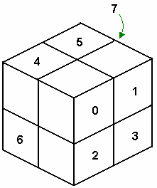

Figure 7 - Subdividing a Volume into Eight Subvolumes to Construct an Octree

OpenGL 3-D Object Functions

The OpenGL library on its own does not provide any routines for drawing 3-D objects – it provides routines for drawing basic primitives such as polygons only and relies on the programmer to construct 3-D objects in the form of polygonal meshes. However, the glut library does provide a number of routines for displaying a range of pre-defined 3-D objects. We can divide these routines into those that draw regular polyhedra and those that draw quadric or cubic surfaces.

Regular Polyhedra

A regular polyhedron is defined as a polyhedron in which all of the faces are regular polygons. A regular polygon is one in which all sides and angles are equal. Regular polyhedra are also called Platonic solids, and there are five in all: the cube, tetrahedron, octahedron, dodecahedron and icosahedron. All can be drawn in either wireframe or solid using glut routines, as summarised in the table below.

Polyhedron | Routine for Wireframe Rendering | Routine for Solid Rendering
Cube | glutWireCube(GLdouble size) | glutSolidCube(GLdouble size)
Tetrahedron | glutWireTetrahedron() | glutSolidTetrahedron()
Octahedron | glutWireOctahedron() | glutSolidOctahedron()
Dodecahedron | glutWireDodecahedron() | glutSolidDodecahedron()
Icosahedron | glutWireIcosahedron() | glutSolidIcosahedron()

Quadric/Cubic Surfaces

A quadric surface is one that can be defined by 2nd order equations, whilst a cubic surface can be defined by a 3rd order equation. The glut library provides routines for drawing a number of quadric/cubic surfaces, although we should remember that actually it will create an approximation of the surface using a polygonal mesh.

Object | Routine for Wireframe Rendering | Routine for Solid Rendering
Sphere | glutWireSphere(GLdouble radius, GLint nSlices, GLint nStacks) | glutSolidSphere(GLdouble radius,  GLint nSlices, GLint nStacks)
Torus | glutWireTorus(GLdouble inRad, GLdouble outRad, GLint nSlices, GLint nStacks) | glutSolidTorus(GLdouble inRad, GLdouble outRad, GLint nSlices,  GLint nStacks)
Cone | glutWireCone(GLdouble baseRad, GLdouble height, GLint nSlices, GLint nStacks) | glutSolidCone(GLdouble baseRad, GLdouble height, GLint nSlices,  GLint nStacks)
Teapot | glutWireTeapot(GLdouble size) | glutSolidTeapot(GLdouble size)

Although these glut routines make it possible to easily add 3-D objects to our scenes, probably the easiest way to quickly construct and visualise a 3-D scene is to use a scene description language. Scene description languages are like programming languages, but they are specifically designed for defining 3-D virtual worlds. Although a range of scene description languages exist, perhaps the most common is VRML (the Virtual Reality Modelling Language), which we will examine in the next chapter.

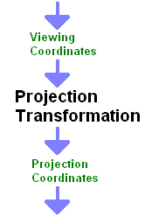
Visible Surface Detection

When primitives are drawn using surface rendering, we do not need to consider the problems of depth perception ambiguity described in Section 2.2, but we do need some way of determining which primitives are visible and which are hidden, so that hidden surfaces can be eliminated from the graphics pipeline. A number of techniques exist for this task, but we can broadly divide them into two categories based on where in the graphics pipeline they occur. Recall from Chapter 5 that the projection transformation transforms points from viewing coordinates to projection coordinates (see Figure 8 right). Visible surface detection can take place in either (or sometimes both) of these coordinate systems. Therefore the two types of visible surface detection technique are:
Figure 8 - The Projection Transformation
- Object-space methods: Visible surfaces are identified in viewing coordinates.
- Image-space methods: Visible surfaces are identified in projection coordinates.
Remember that, in theory, projections are 3-D to 2-D transformations, but we stated in Chapter 5 that the z-coordinate is normally preserved in graphics projections. Now we can see the reason for preserving it: image-space visible surface detection techniques need to be able to access the z-coordinate because it represents the depth of points away from the virtual camera. For primitives that project to the same point in projection coordinates, we need to draw the one with the lowest depth.

Now we will consider three different visible surface detection methods: one is an object-space method, one an image space method, and one is a combination of the two.

Back-Face Detection

Back-face detection is a very simple object-space technique that can eliminate many, but not all, hidden surfaces. Before we describe this technique, first we need to point out an ambiguity in the use of the term back-face in computer graphics. Recall that every surface has an associated surface normal that identifies the front-face of the surface. For solid 3-D objects the front-face is normally the one facing ‘out’ from the surface of the object, whilst the back-face faces the interior of the object and so cannot normally be seen. Occasionally, however, the term back-face is used to refer to the face of a surface that is facing away from the virtual camera, whether or not it is identified by the surface normal as a ‘front-face’. The back-face detection algorithm attempts to identify front-faces (as defined by the surface normal) that are facing away from the virtual camera.

Since back-face detection is an object-space visible surface detection technique, it takes place in the viewing coordinate system. Recall that the viewing coordinate system is a right-handed coordinate system that has its origin at the position of the virtual camera, its negative z-axis along the viewing direction of the camera and the y-axis as the ‘up’ direction of the camera. Likewise, all surface normals will be defined in this viewing coordinate system. Therefore, a quick and easy test to determine if a surface has its front-face facing away from the virtual camera is to check if the z-coordinate of its surface normal is less than or equal to zero. This is illustrated in Figure 9. Here we can see a surface normal N = (A,B,C). Since the camera direction is the negative z-axis, we can say that if C ≤ 0 then the front-face of the surface is facing away from the camera, and therefore can be eliminated.

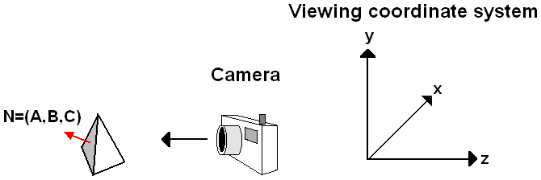

Figure 9 - Back-Face Detection

Back-face detection is an effective way of eliminating back-facing surfaces, but it cannot eliminate all hidden surfaces. Figure 10 shows an example of an occluded face. Here, all three visible faces of the far cube are partially obscured by the near cube. In places where two or more primitives project to the same image coordinate we need some way of determining which one should be displayed. Next we will examine two possible techniques for making this decision.

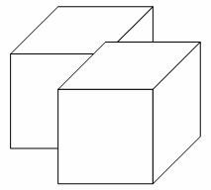
Figure 10 - Occluded Faces

Depth Sorting

The depth-sorting algorithm combines both object-space and image-space operations. The basic algorithm is:
- Surfaces are sorted in object-space according to their depth from the virtual camera.
- All surfaces are scan converted, starting with the most distant and finishing with the closest.
The first of these two steps takes place mostly in object-space, whereas the second takes place in image space. Compare this approach to back-face detection, in which primitives are eliminated before they are scan converted, i.e. it is a purely object-space technique.

Depth-sorting is also sometimes known as the painters algorithm. The reason for this is that it works in a similar way to a painter painting a picture: first the background is painted on the canvas, then distant objects, then closer objects, and so on; each layer can cover up parts of the previous layer, giving the correct occlusion effects.

The sorting of surfaces consists of several steps. First, the surfaces are ordered according to their depth (i.e. z-coordinate in viewing coordinates) from the camera. The point on each surface closest to the camera is used for the purpose of sorting. Next, the surfaces are considered one-by-one in decreasing order of depth: each surface S is checked against every other surface S’ in the list to see if there is a depth overlap between them. A depth overlap occurs if the minimum and maximum z-coordinates of the two surfaces overlap (see Figure 11). If surface S has no depth overlaps with other surfaces in the list then it is considered to be the most distant surface and it is scan converted. If there is a depth overlap between S and another surface S’, the two overlapping surfaces are checked for one of the following conditions:
- The bounding rectangles of the two surfaces in the xy directions do not completely overlap - see Figure 12(a).
- Surface S is completely behind surface S’ - see Figure 12(b).
- Surface S’ is completely in front of surface S - see Figure 12(c).
- The projections of the boundaries of S and S’ onto the image plane do not overlap – see Figure 13. (Note that this is an image-space operation.)
These tests are performed in the order listed. If any one of these conditions is true, then surface S is assumed to be behind surface S’ and we proceed to the next overlapping surface. If all overlapping surfaces have been considered then surface S is scan converted and we move on to consider the next surface in the list. If all of the tests fail then we swap surfaces S and S’ in the ordered surface list and then repeat the tests for the new furthest surface (S’).

The four tests listed above are simple to perform. Test (a) is a simple matter of comparing minimum and maximum x and y coordinates. Tests (b) and (c) can be performed by substituting the vertex coordinates of one surface into the plane equation of the other. For test (d) we must compute line intersections.

The algorithm described above will correctly order most surfaces, but there are some special cases that will not be handled correctly. Figure 14 shows two surfaces that obscure each other: whichever order they are drawn in, one of the two occlusions will not be drawn correctly. In cases like these, we need to detect the mutual occlusion and split one of the surfaces into two.

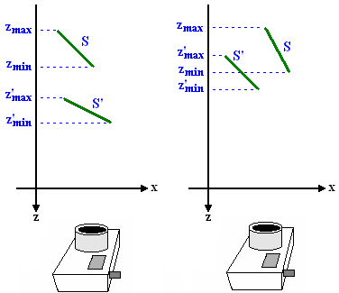

(a) (b)

Figure 11 - Determining Depth Overlap Using z-coordinate Extents: (a) Surfaces Without Depth Overlap; (b) Surfaces With Depth Overlap

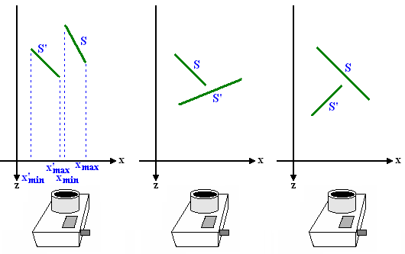
(a) (b) (c)

Figure 12 - Swapping Conditions for Depth-Sorting

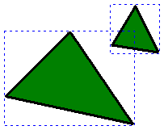

Figure 13 - Two Non-Overlapping Surfaces with Overlapping Bounding Rectangles

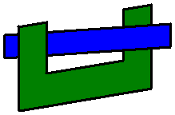

Figure 14 - Two Surfaces That Obscure Each Other

Depth-sorting is an efficient algorithm for performing hidden surface elimination. Performing most elimination in object space gives a reduction in complexity since the number of surfaces is less than the number of pixels in image-space. In addition, depth-sorting allows easy implementation of transparency effects: if a surface is transparent or semi-transparent then instead of overwriting the previous surface(s) intensity, the new intensity is combined with the existing one. However, the test for mutually overlapping surfaces such as that shown in Figure 14 is not straightforward, and the division of a surface into two new surfaces is also computationally complex. Therefore, although depth-sorting is commonly used for transparency effects, another, more efficient, technique is more often used for standard visible surface detection: depth-buffering.

Depth Buffering

Depth-buffering (also known as z-buffering) is a purely image-space visible surface detection technique. It operates by storing depth information for each pixel in the image in a separate frame buffer, known as the depth-buffer or z-buffer. Recall that after projection into image-space the z-coordinate is preserved for use by image-space visible surface detection algorithms such as depth-buffering. Also recall from Chapter 5 that after projection there is a normalisation transformation that scales all coordinates to the range [0,1]. Therefore all coordinates used by depth-buffering are in this range: a z-coordinate of 0 represents a point on the near clipping plane and a z-coordinate of 1 represents a point on the far clipping plane.

The basic depth-buffering algorithm is:
- First, initialise both colour and depth buffers – for all x, y:
  - depthBuffer(x,y) = 1.0 (the maximum possible depth)
  - colourBuffer(x,y) – backgroundColour
- For each surface in the scene:
  - For each projected pixel (x,y), find depth z
  - If z < depthBuffer(x,y)
    - Compute surface colour at (x,y)
    - colourBuffer(x,y) = surfaceColour
    - depthBuffer(x,y) = z

In other words, each time a surface point is projected onto the image plane, we compare the depth of the surface with the current depth of that pixel. If it is less than the current depth then we known that this surface will obscure the previous surface’s value so we overwrite it. Otherwise we leave the buffer value as it is.

Figure 15 illustrates a case in which depth-buffering would be useful. Here we can see that three surfaces, S₁, S₂ and S₃, all project to the same point (x,y) in the image. S₃ would have the lowest z-coordinate of the three, since it is closest to the virtual camera. Therefore, regardless of which order the surfaces are processed in, the pixel at (x,y) will be coloured by the surface colour of S₃.

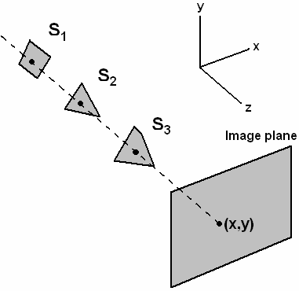

Figure 15 - Occlusion of Surfaces

Depth-buffering is a very simple algorithm and, although it must be performed for every pixel in the image, it is also very efficient, since we do not need to do any pre-processing of surfaces: they can be processed in any order. Depth-buffering is especially efficient if all primitives are polygons, which they normally are in computer graphics. Almost all graphics cards will feature a built-in depth-buffer and will implement the depth-buffering algorithm in dedicated hardware, making it even faster. Although it has a slight overhead in terms of memory, this is the most commonly used visible surface detection algorithm.

An Illumination Model

Now that we have algorithms for determining which surfaces to display, in order to achieve realistic rendering we need a technique for determining what surface colour to assign to each pixel in the image. A number of factors affect how surfaces appear when rendered. Most 3-D scenes will contain at least one, possible several, light sources. The number, position, type and colour of the light sources will have a big impact on how surfaces in the scene appear. In addition, the material properties of the surface are important. For example, is the surface shiny or rough? What colour is it? All of these factors combined are known as an illumination model. In the following sections we examine each of these factors in turn and attempt to construct an overall model of how our scenes are lit.

Light Sources

Broadly speaking, we can identify a number of different types of light source:
- Point light sources – Light sources that have a position in space and give out light equally in all directions. For example, a light bulb can be thought of as a point light source.
- Infinitely distant light sources – Light sources such as the sun, which can be considered to be almost infinitely distant from the scene they are lighting, or at least so far away that we do not need to consider any variation in their directional effects. Such light sources are directional, but have no position.
- Spotlights – These are directional lights that also have a position in space. For example, table lamps or torches are types of spotlight.

In addition to these three types of light source, most graphics packages also consider the effects of ambient light. In real-world scenes, much of the light that is reflected off of a surface does not come directly from any single light source – instead, it is the result of many reflections off of different surfaces. This level of complexity would be very time-consuming to model, so we can simplify our illumination model and include a single term that represents the general brightness in the scene, i.e. light that does not come directly from a light source. This term is known as ambient light.

Many light sources appear brighter if you are close to them or in their direct path. For example, a light bulb is brighter if you are standing 1m away from it than if you are standing 1km away from it. This effect is known as attenuation, and we can identify two different types of attenuation:
- Radial attenuation – Light from the light source gets dimmer as we get more distant from the source – see Figure 16(a).
- Angular attenuation – Light from the light source gets dimmer as we move out of its direct path – see Figure 16(b).
All light sources suffer from radial attenuation, but for infinitely distant sources the effect of radial attenuation within the scene is not noticeable, so normally they are considered to have a constant brightness. Point light sources will suffer from only radial attenuation, whereas spotlights suffer from both radial and angular attenuation.

In order to be able to compute the effects of each light source on a given surface we need a way of calculating the radial and angular attenuation at a given distance/angle. To achieve realistic lighting the following equations are normally used:

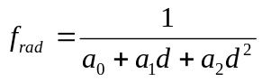 …………………………………………………… (1)

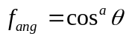, 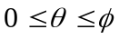 …………………………………………… (2)

In Eq. (1), d is the distance of the surface from the position of the light source as shown in Figure 16(a). In Eq. (2), θ is the angle the surface subtends with the direction of the light source, as shown in Figure 16(b). Often this angle is subject to a maximum limit φ, i.e. the light intensity at any angle greater than φ is zero. The term a in Eq. (2) is known as the attenuation exponent and should be assigned some positive value: if this is high the brightness will fall off rapidly as the angle θ increases.

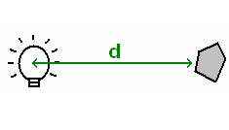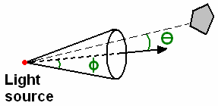
- (b)

Figure 16 - Radial and Angular Intensity Attenuation

Reflection

Once we know the brightness of light reaching a surface, we need to know how this light is reflected off of the surface. This is known as a reflection model. In computer graphics, we normally define two different reflection models for each surface, which represent slightly different types of reflection: diffuse and specular reflection.

Diffuse Reflection

Diffuse reflection occurs when the light photons penetrate a few atoms into the surface of the material before being reflected. If this happens there are two main effects:
- Some frequencies of light are absorbed by the surface causing the reflected light to be a different colour.
- The reflected light is scattered by the atoms so that it reflects more or less equally in all directions.
Diffuse reflection is the dominant form of reflection if the surface is rough or grainy. Examples of diffuse reflection are shown in Figure 21.

Diffuse reflection is usually modelled using Lambert’s Cosine Law. This states that the amount of radiant energy coming from any small surface area dA in a direction φ relative to the surface normal is proportional to cos φ. Notice that it refers to radiant energy, not brightness/intensity. In fact, the brightness of light is calculated by dividing the radiant energy by the visible surface area. And the visible surface area (i.e. dA projected in a direction φ) is also computed using a cosine. This can be seen from Figure 17: if we view a surface area dA along the surface normal the visible surface area is also dA, but as the viewing angle away from the surface normal increases the visible surface area becomes less and less. Therefore, if the visible surface area is also proportional to the cosine of the viewing angle, this means that the actual intensity is constant across all viewing angles. The following steps summarise this argument:

Intensity = Radiant energy per unit time
Projected area

Intensity cos φ
Projected area

Intensity cos φ
dA cos φ

Intensity = constant

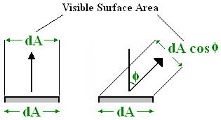

Figure 17 - The Visible Surface Area at a Viewing Angle of φ

In other words, according to Lambert’s Cosine Law, the brightness of reflected light is dependent on the position of the light source and the object but independent of the observer’s position. If the light hits the surface at an acute angle then the amount of light that is reflected, and hence the surface brightness, will be less. But the brightness will be the same when the surface is seen from all viewpoints.

The relationship between angle of incidence and the amount of light reflected from a surface is illustrated in Figure 18: in the top image the angle of incidence is 0º, so the number of light rays hitting the surface is high; as the angle of incidence increases so the number of light rays hitting the surface decreases. The more light that hits the surface the more light is reflected. Therefore we can model the amount of light diffusely reflected from a surface from a light source l as:

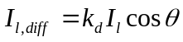 …………………………………………………………… (3)

where I_{l} is the intensity of light hitting the surface, k_{d} is the diffuse reflection coefficient, and θ is the angle of incidence. Similarly, ambient light is diffusely reflected according to the following equation:

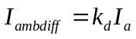 …………………………………………………………………… (4)

where I_{a} is the brightness of ambient light in the scene. Note that ambient light has no direction so we do not consider its angle of incidence.

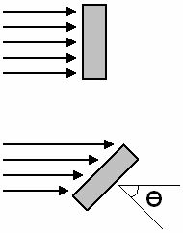

Figure 18 - The Angle of Incidence of Light With a Surface

Specular Reflection

Specular reflection occurs when the light photons reflect off of the top layer of atoms in the surface. If this happens the reflected light is normally
- in the same colour as the incident light, and
- mostly in a specific direction.
The fact that the reflection is directional means that specular reflection causes highlights or bright spots on the surface that will alter as you change your viewpoint. Specular reflection is the dominant form of reflection if the surface is smooth and shiny, and some examples are shown in Figure 21.

The brightness and direction of specular reflection depends on a number of factors:
- The surface normal, N.
- The direction that the light comes from, L.
- The direction of ideal specular reflection, R, which forms the same angle θ with N as the vector that points towards the light source, L.
- The viewing position, V.
This is illustrated in Figure 19. If the surface is an ideal specular reflector then light is only reflected in the reflection direction R. A perfect mirror would be an ideal specular reflector, but most materials reflect light at a range of viewing directions about R. Very shiny surfaces reflect in a narrow range of directions about R, whereas dull surfaces reflect in a wider range of directions.

We can model specular reflection using the Phong specular reflection model:

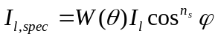 …………………………………………………… (5)

where I_{l} is the intensity of light hitting the surface from light source l, φ is the viewing angle (see Figure 19), and W(θ) is a specular reflection coefficient that determines how the material of the surface reflects light according to the angle of incidence θ. The term n_{s} is known as the specular reflection exponent. Like W(θ), this is dependent on the material of the surface. If the surface is very shiny this will have a high value (such as 100), and if it is dull then n_{s} will have a low value (such as 1).

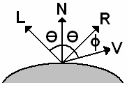

Figure 19 - The Angles of Incidence, Reflection and Viewing for Specular Reflection

As stated above, the specular reflection coefficient W(θ) is dependent on the material of the surface. It’s value will range between 0 and 1, but for many opaque materials W(θ) is almost constant over all values of θ so some graphics packages may make this simplification and use a constant value. Other surfaces, especially (semi-)transparent ones, can have big variations. For example, Figure 20 shows the variation of W(θ) with viewing angle θ for a number of different surfaces.

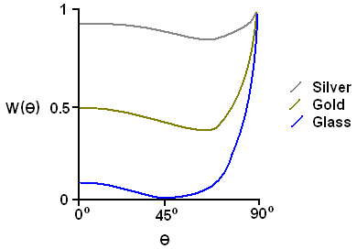

Figure 20 - The Variation of the Specular Reflection Coefficient, W(θ), with Angle of Incidence θ for Some Common Surfaces.

Surface Light Emission

Finally, some scenes may contain surfaces that themselves emit light. For example, neon strip lights could be modelled in this way. Therefore, as well as diffuse and specular reflection we must add to our illumination model a term, I_{surf} ,for such light-emitting surfaces.

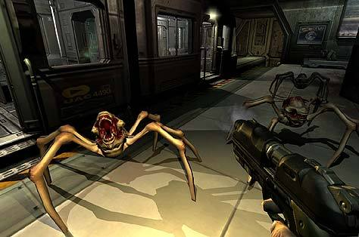
Diffuse reflections
Specular reflections

Figure 21 - Diffuse and Specular Reflections

A Basic Illumination Model

Now we are in a position to combine all of these different light sources to produce an overall illumination model. We model the total brightness I of a surface, due to all light sources in the scene, as the sum of the light emitted from the surface, the ambient light reflected from the surface, and the diffuse and specular reflections from each light source:

…………………………… (6)

Note that the incident light from each source is first attenuated according to its distance and angular separation - f_{l,rad} and f_{l,ang} are the attenuation factors for light source l and are calculated using Eqs. (1) and (2). The terms I_{ambdiff}, I_{l,diff} and I_{l,spec} are as defined in Eqs. (3)-(5).

The OpenGL Illumination Model

OpenGL allows you to define up to eight separate light sources, identified by the symbolic constants GL_LIGHT0, GL_LIGHT1, … , GL_LIGHT7. The OpenGL routine glLight* is used to define properties of these light sources. In addition, we can also define global lighting parameters (i.e. parameters that are not specific to a particular light source) using the glLightModel* routine.

Global Lighting Parameters

The basic format of the glLightModel* routine is:

glLightModel* (paramName, paramValue)

That is, we should call this routine once for each global lighting parameter we want to specify, providing the parameter name and value as arguments. An example of a global lighting parameter is the level of ambient light in the scene. To set this parameter, we can use the following code:

GLfloat globalAmbient[] = {0.0, 0.0, 0.3, 1.0);
glLightModelfv(GL_LIGHT_MODEL_AMBIENT, globalAmbient);

Note, however, that individual light sources also make their own contribution to the ambient light level, so the actual total ambient light is the sum of the contributions of all light sources and this global level.

Individual Light Sources

Individual light source parameters are defined using the glLight* routine. The basic format of this function is:

glLight*(lightName, lightProperty, propertyValue)

That is, for each property we want to set, we must specify the light source, the property name and the property value as arguments when we call glLight*.

There are four steps involved in defining an individual light source in OpenGL:
- Define the type/colour/position of the light source.
- Switch on the light source.
- Enable the OpenGL lighting feature.
- Define the radial attenuation of the light source.

Defining the position and type of the light source is performed using a single call to glLightfv. Recall that light sources can have a position in the scene or be infinitely distant. Using the property name GL_POSITION, we define a 4-D vector as the property value: if the fourth coordinate of the vector is equal to 1 the light source has a position and the first three values represent the coordinates of this position; if the fourth coordinate is 0 then the light source is infinitely distant and the first three values represent a vector indicating the direction of the light source. For example, the following code

GLfloat lightPos1[] = {10.0, 10.0, 10.0, 1.0};
GLfloat lightPos2[] = {0.0, 0.0, 1.0, 0.0};
glLightfv(GL_LIGHT0, GL_POSITION, lightPos1);
glLightfv(GL_LIGHT1, GL_POSITION, lightPos2);

defines two light sources: GL_LIGHT0 is a positional light source located at (10,10,10), whereas GL_LIGHT1 is an infinitely distant source shining along the positive z-axis.

We can define spotlights by specifying a positional light source, and then modifying three extra lighting parameters. These three parameters represent the direction, the cut-off angle φ from Figure 16(b) and the angular attenuation exponent a in Eq. (2). The following code defines a spotlight that shines along the negative z-axis, with a cut-off angle of 25º and an angular attenuation exponent of 2.0.

GLfloat direction[] = {0.0, 0.0, -1.0};
glLightfv(GL_LIGHT0, GL_SPOT_DIRECTION, direction);
glLightf(GL_LIGHT0, GL_SPOT_CUTOFF, 25.0);
glLightf(GL_LIGHT0, GL_SPOT_EXPONENT, 2.0);

In OpenGL we define three different colours for each light source: one for its contribution to the ambient light of the scene, one for light that will be diffusely reflected and one for light that will be specularly reflected. Although real-world light sources do not have three different types of light, this scheme does allow a lot of flexibility in modifying parameters to get the effects we want. Each light colour is defined using a separate call to glLight*. For example,

GLfloat colour[] = {0.5, 0.5, 0.5, 1.0};
glLightfv(GL_LIGHT0, GL_AMBIENT, colour);
glLightfv(GL_LIGHT0, GL_DIFFUSE, colour);
glLightfv(GL_LIGHT0, GL_SPECULAR, colour);

defines all three light source colours to be the same grey colour. Remember that the fourth value of the colour vector represents the alpha value.

We also use glLight* to define the radial intensity attenuation coefficients. Recall that in Eq. (1) there are three coefficients that control the way light gets dimmer with distance from the light source: a₀, a₁ and a₂. These can be set individually using separate function calls as follows,

glLightf(GL_LIGHT0, GL_CONSTANT_ATTENUATION, 1.2);
glLightf(GL_LIGHT0, GL_LINEAR_ATTENUATION, 0.8);
glLightf(GL_LIGHT0, GL_QUADRATIC_ATTENUATION, 0.3);

for a₀, a₁ and a₂ respectively.

The final two steps are straightforward: switch on the light source and enable the OpenGL lighting feature. Both involve a call to glEnable:

glEnable(GL_LIGHT0);
glEnable(GL_LIGHTING);

Material Properties

OpenGL also allows us to specify material properties for surfaces that affect the way they reflect light. These are set using the function glMaterial*, which has the basic format

glMaterial*(surfFace, surfProperty, propertyValue)

The argument surfFace determines which face(s) of the surface will be affected – its value can be GL_FRONT, GL_BACK or GL_FRONT_AND_BACK. The remaining two arguments define a property and a value. Parameters set using calls to glMaterial* will apply to all surfaces subsequently drawn.

We can separately define the following parameters for the material:
- a surface emission colour, I_{surf} from Eq. (6)
- the diffuse reflection coefficient k_{d} from Eqs. (3) and (4)
- a constant specular reflection coefficient instead of W(θ) in Eq. (5)
- the specular reflection exponent n_{s} from Eq. (5)

The following code defines a surface whose front face emits light of the RGB colour (0.1, 0.0, 0.3), and whose front and back faces diffusely reflect with the colour (0.4, 0.3, 0.6) and specularly reflect with the colour (1.0, 1.0, 1.0). The specular reflection exponent is equal to 50. Note that to compute the actual colour of diffusely/specularly reflected light, the diffuse/specular colour of the light source is multiplied by these coefficients.

GLfloat emissionColour[] = {0.1, 0.0, 0.3, 1.0};
GLfloat diffuseCoeff[] = {0.4, 0.3, 0.6, 1.0};
GLfloat specCoeff[] = {1.0, 1.0, 1.0, 1.0};
glMaterialfv(GL_FRONT, GL_EMISSION, emissionColour);
glMaterialfv(GL_FRONT_AND_BACK, GL_AMBIENT_AND_DIFFUSE,
diffuseCoeff);
glMaterialfv(GL_FRONT_AND_BACK, GL_SPECULAR, specCoeff);
glMaterialfv(GL_FRONT_AND_BACK, GL_SHININESS, 50.0);

Surface Rendering

Computing intensities using the illumination model described above takes time, so to increase rendering speed this computation is not normally performed for every point on a surface. The following sections describe three different approaches to rendering surfaces efficiently.

Constant-Intensity Surface Rendering

The simplest approach is to assign the same colour to every projected pixel position for a given surface. This is known as constant-intensity surface rendering, or flat surface rendering. The colour is calculated by taking a single point on the surface, such as one of the vertices or the centre point of the surface, and computing the surface colour at that point. This colour is then use to colour then entire surface. Figure 22(a) shows an example of constant-intensity surface rendering.

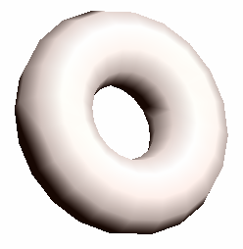
(a) (b)

Figure 22 - A Torus Drawn Using (a) Constant Intensity Surface Rendering, and (b) Gouraud Surface Rendering

Although simple and very fast, we can see from Figure 22(a) that the final effect is not realistic. If the polygons in the mesh are too large the boundaries between surfaces in the mesh are noticeable. Constant intensity surface rendering can be useful when realism is not as important as speed, for example for quick visualization in a CAD program. But for more realistic images, another technique is required.

Gouraud Surface Rendering

Gouraud surface rendering operates by computing the colour at each vertex of the surface, and then performing linear interpolation using these vertex colours to compute a separate colour for each point on the surface. The vertex colours are calculated by first determining a normal vector for each vertex by averaging all polygon normals of which the vertex is a part. These vertex normals, together with the illumination model, are used to compute the surface colour at each vertex. Next, the colour at each point on the surface is computed using linear interpolation. For example, referring to Figure 23, we compute the colour at point P by first interpolating the colours at points 4 and 5, I₄ and I₅, based on the known vertex intensities, I₁, I₂ and I₃:
- I₄ = a/(a+b)I₂ + b(a+b)I₁
- I₅ = c(c+d)I₂ + d(c+d)I₃
Next, the colour at P, I_{P}, is interpolated from I₄ and I₅:
- I_{P} = e(e+f)I₅ + f(e+f)I₄
This computation is performed for each projected surface point, so Gouraud surface rendering is significantly slower than constant-intensity surface rendering, but as we can see from Figure 22(b) the improvement in realism is obvious.

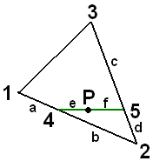

Figure 23 - Using Linear Interpolation in Gouraud Surface Rendering

Phong Surface Rendering

Phong surface rendering provides even more realism than Gouraud surface rendering. To begin with, the normals at the vertices of the surface are calculated, the same as in Gouraud surface rendering. But then these normals are interpolated for each projected point on the surface. The interpolation is performed in the same way as for the colour interpolation in Gouraud surface rendering, except using normal vectors. Then each interpolated normal is used to compute a separate colour at each point using the illumination model.

Although slightly more realistic than Gouraud surface rendering, the increase in computation time for Phong surface rendering is significant: the surface colour has to be computed separately for each pixel, rather than only for each vertex. Therefore Phong surface rendering is only used when realism is more important than rendering speed.

Surface Rendering in OpenGL

OpenGL supports constant intensity surface rendering and Gouraud surface rendering, but not Phong surface rendering. To change the rendering technique we use the function glShadeModel, as follows:

glShadeModel(GL_FLAT); // use constant intensity surface rendering
...
glShadeModel(GL_SMOOTH); // use Gouraud surface rendering

If no calls to glShadeModel are made, the default rendering technique is Gouraud surface rendering.

Ray-Tracing

Ray-tracing is an alternative surface rendering technique that models the way light rays interact with surfaces in the real world much more realistically. Ray-tracing removes the need for visible surface detection algorithms such as depth-buffering or depth-sorting, and also automatically computes shadow effects and handles transparent surfaces. The images it produces tend to be highly realistic, although the computation time involved means that ray-tracing is not currently feasible for real-time graphics. Ray-tracing, or variations on it, is commonly used in the entertainment industry for off-line production of images for realistic animations or special effects.

The basis of the ray-tracing algorithm is that for each pixel in the image a pixel ray is cast from the centre of projection through the pixel position in the image plane and into the 3-D scene. The path of this ray is traced as it is reflected and refracted when it hits the different surfaces in the scene. For each surface it hits, contributions to the pixel intensity are accumulated. This approach is based on the physics of how scenes are lit: in reality there are millions of such rays bouncing around a scene, but the only ones we are interested in are the ones that end up passing through the image plane and hitting the camera. Therefore we trace the paths of these rays backwards from the camera into the scene.

The basic ray-tracing algorithm can be summarised as follows:
- For each pixel in the image, cast a pixel ray from the centre of projection through the pixel in the image plane and into the 3-D scene.
- Compute the intersection point of the pixel ray with the nearest surface in the scene.
- Compute the surface colour at the intersection point using an illumination model, a shadow ray for each light source and 1 or 2 secondary rays:
  - Generate shadow rays from the intersection point to each light source in the scene. If a surface intersects the path of the shadow ray no light will be contributed by the light source and a shadow will result. Otherwise use radial/angular attenuation to compute the colour/brightness of the incoming light from each source.
  - Generate a secondary reflection ray along the direction of ideal specular reflection. Repeat the ray-tracing algorithm to compute the intensity of this ray.
  - If the surface is transparent or semi-transparent, generate a secondary transmission ray by refracting it according to the refraction properties of the material. Repeat the ray-tracing algorithm to compute the intensity of this ray.
- This process should continue until all rays meet one of the following conditions:
  - The ray leaves the scene (set its colour to the background colour)
  - The ray hits a light source (set its colour to the colour of the light source)
  - We reach a maximum number of rays, i.e. the ray has been reflected/refracted more than N times (set its colour to the background colour)
Figure 24 shows the rays generated by casting a single pixel ray into a 3-D scene containing surfaces and light sources. The initial ray will intersect with two different surfaces: the red and blue ones. So we compute the nearest intersection point (on the red surface). This is a semi-transparent surface so we compute the surface colour by generating a secondary reflection ray R1, a secondary transmission ray T1, and shadow rays to the two light sources, S1 and S2. These two shadow rays are used to compute the total light reaching the surface from the two light sources. In this case they do not intersect with any other surfaces so no shadows are produced. The reflection ray R1 leaves the scene so its colour is set to the background colour. The transmission ray T1 intersects with another surface (the blue one). This surface is solid so we compute the surface colour by generating two shadow rays, S3 and S4, and a single secondary reflection ray, R2. Notice that S4 intersects with the green surface and so a shadow will be produced on the blue surface. R2 proceeds to intersect with the yellow surface, producing another secondary reflection ray, R3, and two more shadow rays, S5 and S6. Finally, R3 leaves the scene and so it is set to the background colour. The final colour of the pixel is determined by computing the contributions of all of these rays using the illumination model.

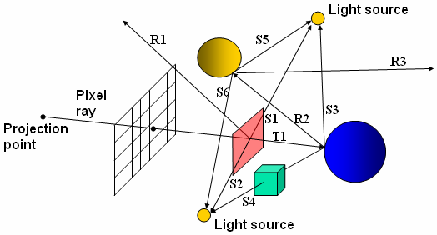

Figure 24 - The Paths of a Single Pixel Ray During Ray-Tracing

Ray-tracing is normally implemented using a data structure known as a binary ray-tracing tree (see Figure 25). This represents the relationships between the reflection and transmission rays generated in the ray-tracing algorithm (it does not store shadow rays, since they never generate secondary rays). Each node in the tree represents a surface, and each arc represents a reflection or transmission ray. When the ray-tracing algorithm is executed, the typical sequence of steps is:
- Trace the pixel ray through the scene and generate the entire ray-tracing tree. When one of the three conditions listed above is met, the ray generates no child nodes and it can be assigned a colour.
- When the entire tree is generated, the colours of the terminating rays are ‘backed-up’ the tree. At each node, a surface colour is computed using the colours of its secondary ray(s) and the illumination model. Eventually the surface colour of the topmost intersected surface in the tree can be computed. This colour is used as the result of the ray-tracing.
Note that the entire binary ray-tracing tree is generated before we start to compute surface colours. This is because we need to know the colours of its secondary rays before we can compute each surface colour.

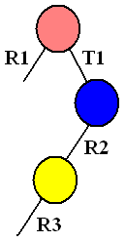

Figure 25 - A Binary Ray-Tracing Tree for the Pixel Ray Shown in Figure 24

Ray-Surface Intersection Calculations

To implement the ray-tracing algorithm, we need some way of computing intersection points of rays with different types of surface primitives in the scene. The general approach to this problem is to use the parametric equation of a straight line to represent the ray, substitute this equation into the equation for the surface, and then solve for the line parameter s. Recall that the parametric equation of a straight line can be written as:

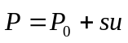 …………………………………………………………………… (7)

where 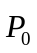 is the start point of the line, is a vector pointing along the direction of the line and s is the line parameter. Typically, for ray-tracing the initial pixel ray, we set to the pixel position in the image plane or the centre of projection. For secondary rays will be set to the surface intersection point. In the following sections we will examine some examples of computing surface intersection points.

Ray-Sphere Intersection Calculations

Points on the surface of a sphere satisfy the equation:

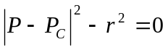 …………………………………………………………… (8)

where r is the radius of the sphere and 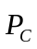 the coordinates of its centre point. Therefore to compute the intersection points of a line with the surface of a sphere we can substitute Eq. (7) for 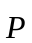 in Eq. (8) and then solve for the line parameter s.

For example, suppose we have a sphere centred at 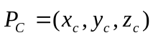 with radius r, and a line starting from 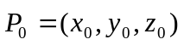 with direction 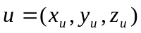. We can substitute Eq. (7) into Eq. (8), as follows:

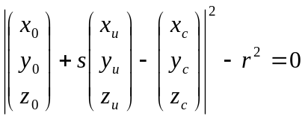 …………………………………………… (9)

This is actually a quadratic equation in s. The form of this equation is 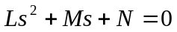, where:

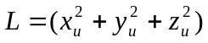 …………………………………………………………… (10)
…………………………… (11)
…………………………… (12)

Therefore we can solve this equation using the standard solution for quadratic equations. Once we have found the values of s for each intersection point, we can substitute them back into Eq. (7) to compute the intersection points. Note that the quadratic equation will provide two solutions - it is normal to get two intersection points of a straight line with the surface of a sphere, as illustrated by Figure 26.

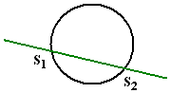

Figure 26 - Intersection Points of a Straight Line With the Surface of a Sphere

Ray-Polyhedron Intersection Calculations

Computing intersection points with a sphere is quick and easy, but most surfaces in 3-D graphics are not spheres, they are polygons. We can compute the intersection point of a straight line with a polygon in a similar way: substitute the parametric line equation into the equation for the plane of the polygon, and solve for the line parameter s. However, if we did this for each ray for every polygon in the scene, it would be time-consuming. Therefore, we first check for intersections with a bounding volume of each polyhedron (polygonal mesh) – if the ray intersects with the bounding volume we perform the polygon intersection calculation for each polygon in the polyhedron, otherwise we do not need to consider them.

We could use a box as the bounding volume, but it is more normal to use a sphere. We define the smallest sphere that encloses all polygons in the polygonal mesh, and then perform the sphere intersection calculation as was described in Section 6.2 above. If the ray intersects with the sphere, then we need to perform further calculations to see if and where it intersections with the polygons.

To find the intersection point of a straight line with a polygon, the first stage is to find the intersection point of the ray with the plane of the polygon. Points on a plane satisfy the equation:

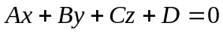. …………………………………………………… (13)

We can rewrite the parametric equation of a straight line given in Eq. (7) to clearly indicate the coordinates of each point/vector:

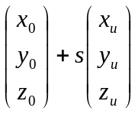 …………………………………………………………………… (14)

Now we substitute Eq. (14) into Eq. (13) to get,

This is a single equation with a single unknown variable, s, so it is straightforward to solve for s. Once we have a value of s at the intersection point, we substitute it back into the parametric line equation to find the intersection point, as was described above in Section 6.2.

Just because a line intersects with a plane, it does not necessarily mean that it will intersect with the polygon itself: it may intersect with the plane at a point outside the polygon boundary. Therefore the next step is to perform an inside-outside test to determine if the intersection point is inside the polygon. We have already examined polygon inside-outside tests in Chapter 2, so a technique such as the odd-even rule or the nonzero winding number rule can be used for this purpose.

Antialiasing Using Ray-Tracing

It is possible to integrate antialiasing directly into the ray-tracing algorithm. The basic operation of antialiasing with ray-tracing is similar to the supersampling technique for normal projections: we calculate pixel colours for a supersampled image, and then assign the final pixel colour using the average of the supersampled pixel values. However, with ray-tracing, calculating the supersampled pixel colours involves casting extra pixel rays into the 3-D scene.

Consider Figure 27. The first stage in producing an antialiased ray-traced image using supersampling is to cast four rays into the scene for each pixel: one at each corner of the pixel boundary. Note that the colour computed from each of these pixel rays can be reused for the other pixels which it borders, i.e. each pixel ray is at the corner of four pixels, apart from those for pixels at the edge of the image. If all four pixel rays produce approximately the same intensity, and if there is no small object that lies in between the four pixel rays, then the four colours are averaged and assigned to the pixel. If there is any significant difference, or if a small object lies between the rays, then we supersample the pixel, for example into a 3x3 grid, and repeat the ray-tracing process. For each of these supersampled pixels 4 pixel rays are cast into the scene (making 16 rays in all in Figure 27(b)), and their resultant colours averaged to produce the final pixel colour.

A common approach to use with this technique is known as adaptive sampling. In this variation of supersampling, we can further subdivide the supersampled pixels using the same technique, but we only do this if their four pixel rays have a significant difference in the colour computed. In this way, we can have different levels of supersampling for different parts of the pixel – this can be useful, for example, in computing antialiased object boundaries. This is illustrated in Figure 28: we can see that the original pixel was supersampled into a 3x3 grid, but then four of the supersampled pixels were subdivided again into 3x3 grids, and finally six of the new supersampled pixels were subdivided once more. The supersampling process continues until either there is no significant difference between the colours of the pixel rays for all supersampled pixels, or some maximum supersampling limit is reach, e.g. 256 rays for a single original pixel. Once the process is finished, the final pixel colour is determined by a weighted average of all rays.

Ray-Tracing Software

Most graphics packages, including OpenGL, concentrate on producing realistic graphics in real-time, so they do not provide implementations of ray-tracing. Ray-tracing is more useful for producing highly realistic images off-line, i.e. not in real-time. Separate software is generally required to perform ray-tracing.

The POVRAY ray-tracing software is completely free and installation files for Windows, Mac and Linux are available for download from www.povray.org (the Windows installation file size is about 10MB). It is open-source software, so the source code is also available for download. POVRAY features its own scene description language that you can use to describe 3-D scenes. Realistic images such as those shown in Figure 29 can be produced in anything from a few seconds to a few minutes.

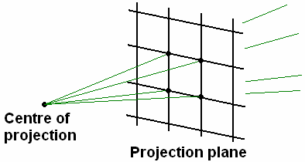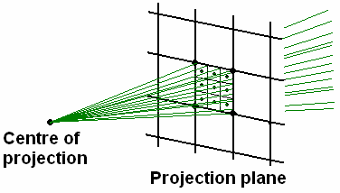

(a) (b)

Figure 27 - Antialiasing Using Ray-Tracing: (a) Four Pixel Rays are used for each Pixel; (b) Supersampling – Each Pixel is divided into a 3x3 Grid and Ray-Tracing Repeated.

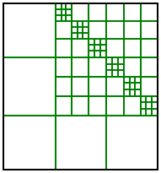

Figure 28 - Adaptive Sampling

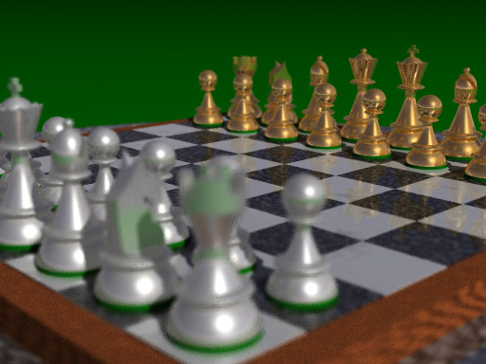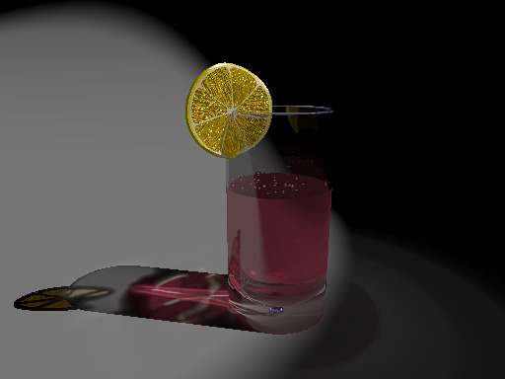

Figure 29 - Sample Images Generated By Ray-Tracing

Texture Mapping

We have already seen in Chapter 3 how we can add a pattern to fill-area polygons. In OpenGL this is done using the glPolygonStipple routine. However, the most common and flexible technique for giving texture to surfaces is known as texture mapping. Texture mapping allows us to specify an image that should be mapped onto the surface of an arbitrarily complex surface. We can even control precisely how this mapping occurs. Consider Figure 30. Figure 30(a) shows an image defined in 2-D texture space. Texture space is basically a 2-D coordinate system in which the two coordinates, s and t, vary between 0 and 1. Figure 30(b) shows a 3-D cube with the texture image mapped onto one of the surfaces of the cube. The four corners of the cube have coordinates in 3-D object space, so to define the mapping from texture space to object space all we need to do is to specify corresponding texture coordinates for these four corners. Any pixels that lie in between the vertices of the surface will have texture coordinates linearly interpolated based on the vertex texture coordinates.

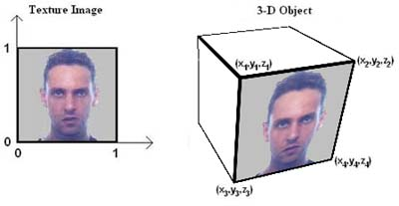
(a) (b)

Figure 30 - Texture Mapping: (a) Texture Space; (b) Object-Space

Figure 31 shows this process in more detail. The tables to the left show the corresponding object and texture coordinates required to produce the images shown to the right. Notice in the top table that the texture coordinates specified vary in the range [0,1], which we can see from Figure 30(a) are the limits of the image in texture space. Therefore the image fits the surface exactly. In the bottom table the texture coordinates vary in the range [0,5], which is beyond the extent of the texture image. If this happens, the texture image is assumed to repeat multiple times in texture space, resulting in the tiled effect shown in Figure 31. The opposite effect can be achieved if we specify texture coordinates in a range less than [0,1] – in this case the texture image will appear magnified and will not fill the entire surface.

As was stated above, texture coordinates are normally defined for vertices only. Any point on the surface that is not one of the vertices will have a texture coordinate interpolated based on the vertex texture coordinates. For example, Figure 32 shows a surface whose vertices have 3-D object-space coordinates (10,10,10), (15,10,10), (10,15,10) and (15,15,10). These vertices have the texture coordinates (0,0), (2,0), (0,2) and (2,2) respectively. To compute the texture coordinate of the point on the surface marked in red, we perform linear interpolation as follows:

.

In other words, we form the new texture coordinates by taking a combination of the texture coordinates of the vertices. We take a large proportion of a texture coordinate if the point is close to its vertex. This process is basically the same as the linear interpolation described for intensities in the Gouraud surface rendering model (see Section 5.2 and Figure 23).

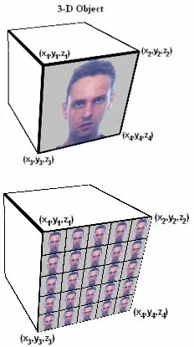

3-D Object Coordinates: x,y,z | 2-D Texture Coordinates: s, t
(x₁,y₁,z₁) | (0,1)
(x₂,y₂,z₂) | (1,1)
(x₃,y₃,z₃) | (0,0)
(x₄,y₄,z₄) | (1,0)

3-D Object Coordinates: x,y,z | 2-D Texture Coordinate: s, t
(x₁,y₁,z₁) | (0,5)
(x₂,y₂,z₂) | (5,5)
(x₃,y₃,z₃) | (0,0)
(x₄,y₄,z₄) | (5,0)

Figure 31 - Tiling of Textures by Modifying Texture Coordinates

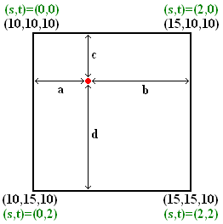

Figure 32 - Linear Interpolation of Texture Coordinates

Texture Mapping in OpenGL

Texture mapping can be applied in OpenGL in four stages:
- Specify a texture image
- Specify interpolation options
- Enable the OpenGL texture mapping feature
- Define texture coordinates for vertices in our scene.

To specify a texture image we must first have read in the bitmap image data from a file. The following function call can be used to define the current texture image, assuming that texArray is a pointer to an array of RGB unsigned byte image data.

glTexImage2D(GL_TEXTURE_2D, 0, GL_RGB, texWidth, texHeight, 0, GL_RGB,
GL_UNSIGNED_BYTE, texArray);

The arguments texHeight and texWidth define the width and height of the texture image in pixels. GL_RGB indicates that each pixel will have 3 values in the bitmap data: one each for the red, green and blue components. Finally, GL_UNSIGNED_BYTE means that each value will be of type unsigned byte.

We must also specify interpolation options for the texture mapping. These basically define what happens when a pixel in the texture image (also known as a texel) does not map directly to a pixel in the image. We need to define two types of interpolation. First, what should happen when the image pixel being mapped corresponds to an area less than one texel? Second, what happens when the image pixel being mapped corresponds to an area larger than one texel? The following two lines of code tell OpenGL that in both cases it should just use the nearest texel value.

glTexParameteri(GL_TEXTURE_2D, GL_TEXTURE_MAG_FILTER, GL_NEAREST);
glTexParameteri(GL_TEXTURE_2D, GL_TEXTURE_MIN_FILTER, GL_NEAREST);

Instead of GL_NEAREST, we could have chosen to use linear interpolation by supplying the argument GL_LINEAR.

Enabling the OpenGL texture mapping feature is straightforward – just like enabling any other feature we use the glEnable routine:

glEnable(GL_TEXTURE_2D);

Finally we need to define 2-D texture coordinates for every vertex of every polygon in our scene. We do this using the routine glTexCoord*. For example,

glTexCoord2f(s, t);

will define the texture coordinate of the next vertex drawn to be (s,t). Remember that we should make a call to glTexCoord* before each vertex we define, not after.

Animation

Animation refers to any time sequence of visual changes in a computer-generated image. The changes can be the result of objects moving or being transformed, or the result of movement of the virtual camera. We can identify two types of animation:
- Real-time animation: The different frames in the time sequence are displayed as they are generated.
- Frame-by-frame animation: The different frames in the time sequence are generated off-line, and then displayed in sequence at a later time.

Graphics packages such as OpenGL are commonly used for generating real-time animations, whereas frame-by-frame animations are normally generated by more realistic but time-consuming algorithms such as ray-tracing. Real-time animations are common in computer games and visualisation applications. Frame-by-frame animations are commonly used in the film industry to produce special effects or animated films.

Double-Buffering

Raster display systems normally produce real-time animations using a technique known as double-buffering. Normally, when no animations are required, raster systems use a single frame buffer, also known as a refresh buffer, to store the image ready for display. It would be possible to produce real-time animations by simply overwriting the refresh buffer with each new frame. However, this would not result in a smooth animation sequence because some primitives would be drawn (and hence displayed) sooner than others. Therefore the normal approach is to use two refresh buffers. First a frame is created in the first buffer; then, whilst this is being displayed, the next frame is generated in the second buffer. Once this frame is ready, we swap buffers to display the newly generated frame. Whilst this is being displayed we generate the next frame in the first buffer, and so on. Using this technique produces much smoother-looking animation sequences, as the entire frame is drawn at the same time (when the buffers are swapped).

Animation in OpenGL

OpenGL allows us to create animations using double-buffering. There are basically three things we need to do to create an OpenGL animation:
- When initialising OpenGL/glut, we must state that we want to create two refresh buffers.
- In the display callback function, we should update the position of the primitives or virtual camera each time it is called. After drawing all primitives, we must swap the refresh buffers.
- We must make sure that the display callback function is called constantly, rather than just whenever OpenGL determines that a refresh is required.

The initialisation of the frame buffers is performed using the following line:

glutInitDisplayMode(GLUT_RGB | GLUT_DOUBLE);
In particular, we must use the symbolic constant GLUT_DOUBLE somewhere in the argument list to specify that we want a double frame buffer. The code given above creates two RGB frame buffers.

Next, at the end of the display callback function, we must make a call to the glut routine that swaps the refresh buffers, and hence draws the new frame:

glutSwapBuffers();

Finally, we have to tell OpenGL to call the display callback function whenever it can. We do this using a special callback function called the idle callback. The idle event occurs whenever OpenGL hasn’t got anything else to do. So if we define an idle callback function it will be called constantly, provided OpenGL isn’t busy doing something else. To tell OpenGL to call the display callback function whenever it is idle we use the following lines:

static void idle(void) {
glutPostRedisplay();
}
…
glutIdleFunc(idle);

The function glutPostRedisplay() tells OpenGL to force a redisplay at the next convenient moment. In other words, we define a function that just tells OpenGL to redisplay, and then specify this function as the idle callback function. Effectively, we are telling OpenGL that whenever it is idle it should redisplay the window. Note that we could have just called the display callback function directly from within the idle function, but this is not the most efficient way to do it.

Summary

The following points summarise the key concepts of this chapter:
- Surfaces can be drawn using wireframe or surface rendering.
- Depth cueing is a technique that helps depth perception by reducing the brightness of primitives that are further from the camera.
- Fogging is a depth cueing technique for surface rendering that increases the realism of 3-D scenes.
- When using wireframe rendering, visible primitives can be identified by drawing ‘hidden’ primitives using a different intensity, colour or line-style.
- 3-D objects can be represented using a boundary representation (b-rep) or a space-partitioning representation.
- Polygonal meshes and spline patches are examples of b-reps.
- The octree is an example of a space-partitioning representation.
- The glut library features and range of routines for drawing regular polyhedra, quadric and cubic surfaces using polygonal meshes.
- Visible surface detection, or hidden surface elimination, is the process of removing from the graphics pipeline surfaces that cannot be seen by the virtual camera.
- Visible surface detection techniques can be classified as object-space methods or image-space methods.
- Object-space visible surface detection techniques take place before the projection transformation, in viewing coordinates.
- Image-space visible surface detection techniques take place after the projection transformation, in projection coordinates.
- Back-face detection is an example of an object-space visible surface detection technique.
- Depth-sorting is a visible surface detection technique that operates in both object-space and image-space.
- Depth-buffering is an example of an image-space visible surface detection technique.
- An illumination model is a mathematical model of light sources, reflections and material properties that can be used to compute the colour of an given surface point in a scene.
- Light sources can be either point sources or directional sources:
  - Point sources have a position in space and emit light equally in all directions.
  - Directional sources emit light mostly in a particular direction.
- Directional light sources can either have a position in space (spotlights) or they can be infinitely distant.
- Spotlights and point light sources suffer from radial intensity attenuation: light appears dinner further away from the source
- Spotlights suffer from angular intensity attenuation: light appears dimmer as the angle away from the direction of the light increases.
- Ambient light refers to the general level of lighting in a scene.
- When light is reflected from a surface the reflection can be either diffuse or specular.
- Light that is diffusely reflected is scattered equally in all directions in a colour determined by the surface material properties.
- The intensity of diffusely reflected light is proportional to the cosine of the angle of incidence of the light.
- Light that is specularly reflected is reflected mostly in a single direction, and is usually in the same colour as the incident light.
- A basic illumination model can be formed by combining the effects of diffusely reflected light (including ambient light), specularly reflected light and surface light emission.
- Given a surface point in the scene and the surface normal at that point, the illumination model can be used to compute a surface colour.
- Parameters of individual light sources in OpenGL can be specified using the glLight* routine.
- Global lighting parameters can be specified in OpenGL using the glLightModel* routine.
- Material properties can be specified in OpenGL using the glMaterial* routine.
- Surface rendering, or surface shading, refers to algorithms for assigning a colour/intensity to each projected pixel in a surface.
- There are three common techniques for surface rendering: constant intensity surface rendering, Gouraud surface rendering and Phong surface rendering.
- In constant intensity surface rendering, the illumination model is used to compute a single colour (usually for the centre point of the polygon) – this colour is used for every pixel in the projected surface.
- In Gouraud surface rendering, the surface colour is computed at each vertex based on the surface normals, and then colours are linearly interpolated for other points on the surface.
- In Phong surface rendering, surface normals are computed at each vertex, and then a normal is linearly interpolated for every other projected pixel in the surface. The illumination model is applied separately for every pixel.
- The glShadeModel routine is used to specify a surface rendering technique in OpenGL.
- Ray-tracing is alternative image generation algorithm that simulates the bouncing of light rays around a scene before they hit the image plane.
- Ray-tracing generates highly realistic images, but it is a computationally complex algorithm so it is not feasible to use it for real-time graphics.
- When a pixel ray hits a surface in ray-tracing, secondary reflection and transmission rays are generated.
- In ray-tracing, the colour at a given surface intersection point is determined using an illumination model, the secondary rays, and a shadow ray for each light source in the scene.
- Ray-tracing is normally implemented using a binary ray-tracing tree.
- Antialiasing can be integrated into the ray-tracing algorithm by supersampling a pixel and generating extra pixel rays for the supersampled pixels.
- Texture mapping is a technique that ‘maps’ a texture image onto a surface to make it appear more realistic.
- In texture mapping, the texture image is specified in 2-D texture space, where texture pixels (texels) are normally indexed by s and t coordinates.
- In 3-D object space, vertex points are assigned corresponding texture coordinates. Points between vertices have texture coordinates assigned by interpolation.
- By scaling texture coordinates, a tiling effect of the texture image on the surface can be produced.
- To perform texture mapping in OpenGL, we use the routines glTexImage2D, glTexParameter* and glTexCoord*.
- Graphics animations can be either real-time animations or frame-by-frame animations.
- In real-time animations, the pictures are displayed as they are generated.
- In frame-by-frame animations, the pictures are generated off-line, and then combined into an animation at a later time.
- Double-buffering is a technique used by raster display systems to produce smooth animations.
- OpenGL implements double-buffering for animation.

Exercises

- Suppose we have three surfaces in a scene that all project to the same region of the image. The projected positions in the image are illustrated by the figure below.

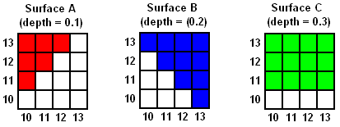

All pixels in surface A will be drawn in red, all pixels in surface B in blue, and all pixels in surface C in green. The normalised depths of each surface are shown in the figure. Assuming that the surfaces are drawn in the order C, A B, explain how the depth-buffering algorithm would produce the correct occlusions.

- In depth buffering, does it make any difference which order the surfaces are rendered in?
- Consider the arrangement of surfaces shown in the figures (a) and (b) below. For each, explain how the depth-sorting algorithm would order these surfaces for scan-conversion.

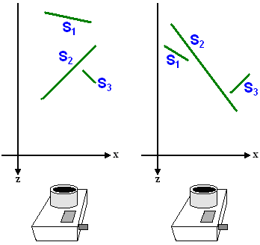
(a) (b)

- Suppose we have a sphere centred at 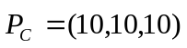 with radius 8, and a straight line starting from 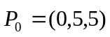 with direction 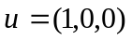. Compute the intersection points of the straight line with the surface of the sphere.

- Suppose that we are using the ray-tracing algorithm and the centre of projection is at the origin (0,0,0). The camera direction is the negative z-axis and we are casting a pixel ray through the centre of the image plane (i.e. along the negative z-axis). There is a polygon in the scene that has the plane equation 5x -2y +3z – 10 = 0. Compute the intersection point of the pixel pay with the plane of the polygon.

- Included in the zip file for this handout in some code for a program that produces an animated scene with several texture mapped surfaces (in the folder Chapter 7 Exercise 6). Examine the code to make sure you understand how the texture mapping and animation is working. Then try to make the following modifications:

  - Try making the texture-mapped bricks on the walls of the room larger.
  - Add an extra animation to the scene, so that the picture hanging on the wall swings from side to side.

  - Try to find an image of some wood texture (e.g. from the Internet), and use it to texture map onto the doorway of the room

Exercise Solutions

- First the colour buffer would be initialised to some background colour (let’s say white) and the depth buffer would be initialised to the maximum normalised depth 1. Next, we render all of surface C in green, replacing the corresponding depth buffer values with 0.3. Next, all of surface A is rendered since its depth value is less than that of surface C and the background. The corresponding depth values are replaced with 0.1. Finally, surface B is rendered, but only in those pixels with a depth buffer value greater than 0.2 – in other words, it will overwrite background pixels and pixels from surface C, but not those from surface A. This is summarised in the figure below.

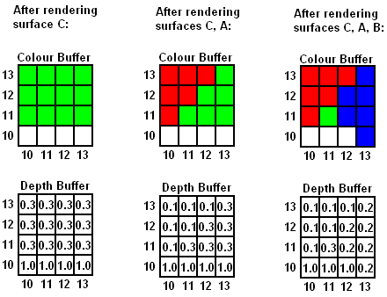

- No it doesn’t. Try it yourself – go through the example from Exercise (1) with a different ordering and you will find the result is the same. This is one advantage of depth-buffering – no pre-processing of surfaces is required.

- The answers are:

  - The initial ordering (based on minimum z-coordinate, most distant surface first) is S₁, S₃, S₂. Then the sequence of steps is:
Consider S₁:
No depth overlap with S₃.
No depth overlap with S₂.
Therefore we draw S₁ and move to next surface in list.
Consider S₃:
Depth overlap with S₂, so perform the four tests (a)-(d):
Test (a): Bounding rectangles do overlap, so False
Test (b): S₃ not completely behind S₂, so False
Test (c): S₂ not completely in front of S₃, so False
Test (d): Boundaries do overlap, so False
Therefore we swap S₃ with S₂, producing the new list S₂, S₃.
Consider S₂:
Depth overlap with S₃, so perform the four tests (a)-(d):
Test (a): Bounding rectangles do overlap, so False
Test (b): S₂ not completely behind S₃, so False
Test (c): S₃ is completely in front of S₂, so True
Stop testing and move on to compare S₂ with next surface
No more surfaces to compare with, so draw S₂.
S₃is the only surface left in the list, so draw S₃.
Therefore the final order of scan conversion was S₁, S₂, S₃.

  - The initial ordering (based on minimum z-coordinate, most distant surface first) is S₁, S₃, S₂. Then the sequence of steps is:

Consider S₁:
No depth overlap with S₃.
Depth overlap with S₂, so perform the four tests (a)-(d):
Test (a): Bounding rectangles do overlap, so False
Test (b): S₁ not completely behind S₂, so False
Test (c): S₂ not completely in front of S₁, so False
Test (d): Boundaries do overlap, so False
Therefore we swap S₁ with S₂, producing the new list S₂, S₃, S₁.
Consider S₂:
Depth overlap with S₃, so perform the four tests (a)-(d):
Test (a): Bounding rectangles do overlap, so False
Test (b): S₂ not completely behind S₃, so False
Test (c): S₃ not completely in front of S₂, so False
Test (d): Boundaries do overlap, so False
Therefore we swap S₂ with S₃, producing the new list S₃, S₂, S₁.

Consider S₃:
Depth overlap with S₂, so perform the four tests (a)-(d):
Test (a): Bounding rectangles do overlap, so False
Test (b): S₃ is completely behind S₂, so True.
Stop testing and move on to compare S₃ with next surface
No depth overlap with S₁.
Therefore we draw S₃ and move to next surface in list.
Consider S₂:
Depth overlap with S₁, so perform the four tests (a)-(d):
Test (a): Bounding rectangles do overlap, so False
Test (b): S₂ not completely behind S₁, so False
Test (c): S₁ is completely in front of S₂, so True
Stop testing and move on to compare S₂ with next surface
No more surfaces to compare with, so draw S₂.
S₁ is the only surface left in the list, so draw S₁.
Therefore the final order of scan conversion was S₃, S₂, S₁.

- Based on the information given, we have x₀=0, y₀=5, z₀=5, x_{u}=1, y_{u}=0, z_{u}=1, x_{c}=10, y_{c}=10 and z_{c}=10. Therefore we can substitute the parametric line equation into the sphere equation (as discussed in Section 6.2) and solve the resulting quadratic equation. Referring to Eqs. (10)-(12), we have

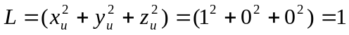

Now, solving for s using the standard solution for quadratic equations we get:

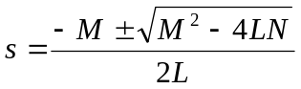

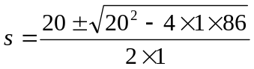

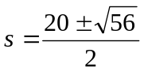 = 13.74 and 6.26

So we get two solutions: s=13.74 and s=6.26. Substituting these back into Eq. (7) we find the intersection points are at:

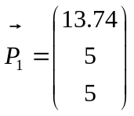
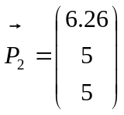

- First we express the pixel ray using the parametric equation of a straight line,, where

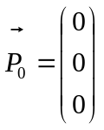, 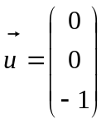,

since the centre of projection is at the origin and the pixel ray is cast along the negative z-axis.

Next, we substitute the parametric line equation into the plane equation. We get:

5(0 + 0s) – 2(0 + 0s) + 3(0 + 1s) – 10 = 0

Therefore we find that s = 3.33 at the intersection point.. Now substituting this back into the parametric line equation we get:

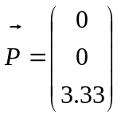

- The following are brief descriptions of the code modifications:

  - Edit the DrawRoom() function: when glTexCoord2f is used to define texture coordinates for the corners of the GL_QUADS primitives that forms the walls of the room, modify the texture coordinates supplied. To make the bricks bigger you must reduce the texture coordinates. E.g. try using (0,0), (2,0), (2,2) and (0,2) instead of (0,0), (3,0), (3,3) and (0,3).

  - You can achieve this by modifying the DrawRoom() function. Before displaying the string and the picture, apply a rotation transformation to the modelview matrix. Remember that the rotation should be about the pivot point of the string (i.e. where the nail that the picture hangs from would be). You will need to define a global variable for the angle of rotation, and then update this for each frame.

The solution for this problem is included in the zip file with this handout – in the folder Chapter 7 Exercise 6b. Global variables pictureAngle and pictureAngleOffset were added, and changes made in DrawRoom() to rotate the picture, and in display() to update the picture angle.

  - No solution for this one – try it out yourself!

Source: Teaching material produced By Andy King (PhD)
Based on the book quoted Below:
Computer Graphics with OpenGL,
Donald Hearn and M. Pauline Baker,
Prentice-Hall, 2004 (Third Edition)

